vRig General Description

Overview
This software project is intended to provide a Drilling Rig Simulation with focus on:
- Rig Sensors
- Drilling Performance
- Directional Drilling Control
- Formation Evaluation and Interpretation
When completed, the target audience will be:
- Training Environments
- Well Plan Testing
- Drilling Performance Optimization

General Description
The software has a number of components, including:
- A Graphic User Interface
- A Simulation Engine
- A Data Storage system
Each component may be composed of several sub-components.

Simulation Engine
Starting with the Simulation Engine description, this item calculates a series of “responses” to events that occur during the drilling process.
Core responses include “Counts” which would be observed by Rig Sensors during an observation period.
A typical drilling rig would contain various sensors which create electronic signals, either digital or analog, for a parameter which they measure. The electronic signals can be converted to a number representing a count, correlating to the strength of the signal. Typically, signals are sampled and converted at a rate of 20 times per second, or 20 hz.
The sensors are monitoring various drilling rig conditions. These include:
- Hookload – a pressure cell mounted on the deadline cable which deflects and exerts pressure on the cell based upon the tension upon the cable. This represents the total load which is being suspended by the travelling block, including the drill string weight.
- RPM – this is a simple sensor that counts the turning of the rotary table when the rotary is turning the drill pipe.
- Torque – a sensor which measures electric current that is applied to the Rotary drive motor. While rotating, the motor may require more current to turn when there is greater resistance to the turning, such that the drive amperage can infer the amount of torque applied.
- Pump Stroke Counters – simple switch devices that turn on and off with each stroke of the mud pumps. Each pump displaces a known volume per stroke, such that monitoring the stroke counts in a given period of time allows calculation of the mud flow rate.
- Drawworks Encoder – This is a complex sensor which measures the vertical movement of the traveling block. The block is suspended via a multipart cable which passes between the traveling block and the crown. One end of the cable is fixed to the rig floor, as the deadline, and the other end of the cable is spooled around a cable drum in the Drawworks. As the Drawworks turns, cable is spooled in or out, allowing the traveling block to move. A sensor is attached to the axel of the Drawworks drum, and rotates along with the drum. A slotted disk in the sensor them rotates in sync with the drum. A light sensor is separated from a light source, separated by the slotted disk, such that the rotating disk creates light pulses which are the counts, correlating to the drum rotation, which in correlates to the cable motion, which correlates to the block motion.
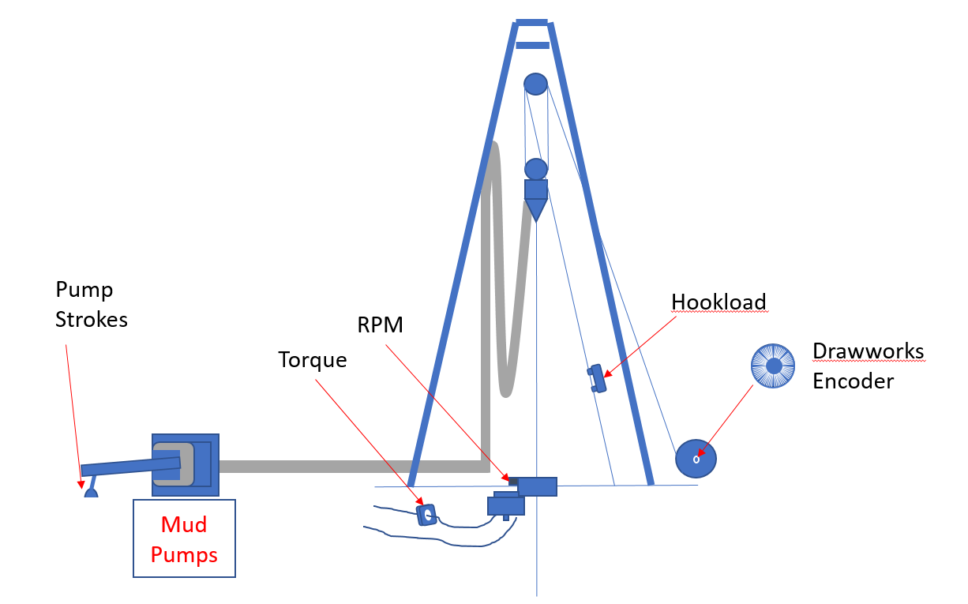

During operation, the simulator engine cycles through a series of loops, corresponding to the sampling interval of 50 milliseconds, or 20hz sampling.
Calculations are performed to adjust items which are being monitored and the number of counts for the sensors are computed. Some of the monitored items are updated, and the looping cycles continue until a threshold is met to move to the next phase of the drilling cycle.
The counts computed will be dependent upon a variety of factors, not the least of which is the phase of the drilling cycle at that point in time.

The Drilling Cycle
The Drilling Cycle is broken into discreet steps needed to drill a single joint of drill pipe. (Note: The description here is for a conventional rig which drills using single joints and a Kelly. Top Drive rigs have a slightly modified sequence). The cycle can be visualized as a chart which tracks the Block height versus Time. Such a chart can be represented like this:
9
2
1
3
4
5
6
7
8
11
10

During the drilling of a single joint, there are distinct steps. The performance of the sensors will vary depending upon the step. The trigging event will vary based each step.
- Initial Start – Making a connection at the start of the drilling
  - Block Motion – not moving
  - Hookload – Equals Block Weight
  - Pumps – Off
  - Rotary – Off
  - Triggered by – Time (Initial Connection Time)
- Pickup Out of Slips – Lifting the drill string up high enough to pull the slips
  - Block Motion – move up about 1 foot
  - Hookload – Picks up to total string weight, plus upward drag
  - Pumps – Off
  - Rotary – Off
  - Triggered by – Block travel upwards
- Run In Hole – Move the string down until the Pipe/Kelly joint is at the rig floor
  - Block Motion – Moving downward until Block position is a length of Kelly
  - Hookload – total string weight less drag
  - Pumps – Off
  - Rotary – Off
  - Triggered by – Block Height
- Take Survey
  - Block Motion – Block held still
  - Hookload – total string weight
  - Pumps – initially off, come after a short wait period
  - Rotary – off
  - Triggered by – Time, waiting for “Survey Time”
- Run In/Tag Bottom
  - Block Motion – Moving downward
  - Hookload – total string weight less drag
  - Pumps – On
  - Rotary – Initially off, start up and then continue
  - Triggered by – Continues until Bit Depth reaches last hole depth
- On Bottom Drilling
  - Block Motion – moving downward, based upon ROP (Rate of Penetration) Calculation
  - Hookload – total string weight less drag, less Weight on bit
  - Pumps – On, but controllable by user
  - Rotary – On, but controllable by user, may orient for sliding, etc
  - Triggered by – Continues until Block Height shows Kelly down
- Kelly Down/Circulating
  - Block Motion – Not moving
  - Hookload – total string weight
  - Pumps – On
  - Rotary – On
  - Triggered by - Timer, continues until Time out of “Circulating Time”
- Pull Out of Hole
  - Block Motion – Moving up
  - Hookload – string weight plus drag
  - Pumps – On initially, then cut off
  - Rotary – On initially, then cut off
  - Triggered by – block height travels Kelly length plus enough to set slips (about 1 foot)
- Set Slips
  - Block Motion – downward about 1 foot
  - Hookload – drops to block weight
  - Pumps – off
  - Rotary – off
  - Triggered by – Block motion
- Break Connection
  - Block Motion – no motion
  - Hookload – block weight
  - Pumps – off
  - Rotary – off
  - Triggered by – Timer, time out of “Connection Time”
- Pick Up for next Joint
  - Block Motion –Move up length of next Joint of Pipe (from Talley)
  - Hookload – block weight
  - Pumps – off
  - Rotary – off
  - Triggered by - Block motion achieving target block height
In addition to the sensor counts, the simulator engine will determine the survey values when a survey is taken and will update a survey table.
While on bottom drilling, as the Bit advances each defined sample interval, the engine will calculate the formation measurements that would be seen by evaluation tools, (e.g. Resistivity, Porosity, etc.) from the formation model, and determining the location of the formation sensor within the model. These measurements will be saved into a Logging data table.
Also, as the Bit advances through the formation, each sample interval will calculate a “micro-survey” or the position of the bit, based upon directional drilling inputs (e.g. Sliding orientation etc.) These values are stored in a “Blind Hole” data set. The purpose of this is to accurately provide the survey data needed when the survey point reaches that interval. The survey values will reflect the trajectory changes based upon the directional drilling changes that we made during the simulator operation.

The Graphic User Interface
The Graphic User Interface is the display system to provide feedback to the operator, and provide the opportunity for interaction. The displays include various Gauges and Digital Displays for monitoring the rig’s activity. Also included are Control Knobs, Sliders and Text Input to allow the operator to control the pumps, hookload, and rotary.
Other displays include a Toolface display, a Rig visualization, and depiction of Drawworks, showing animations of the rig activity.
The main window provided menus and forms to access setup and management of wells and associated items.
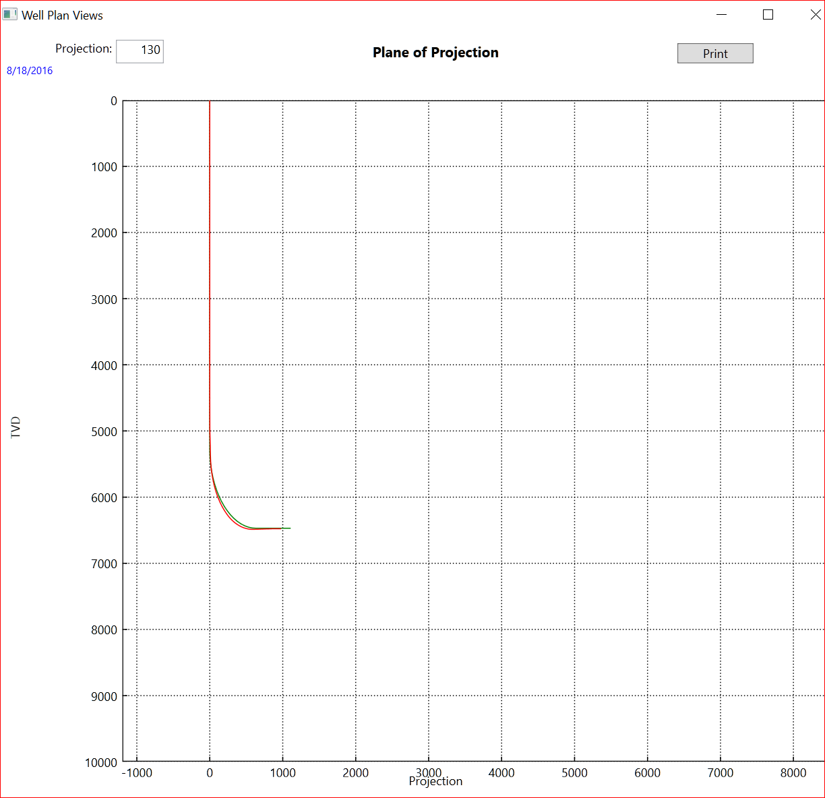
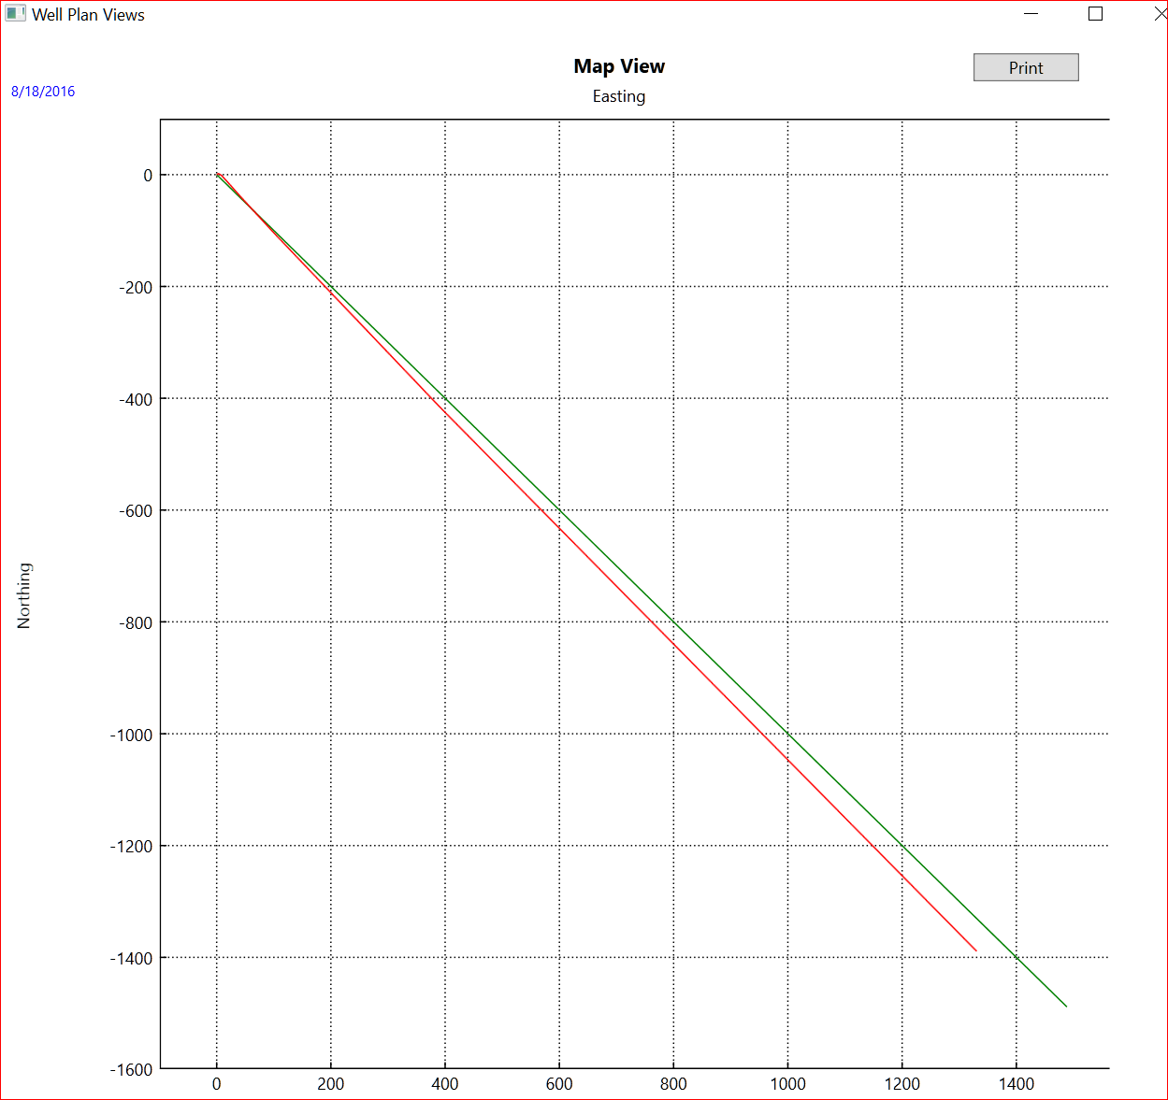
Additional graphic outputs include Well Plan

and Formation Logging Data displays.
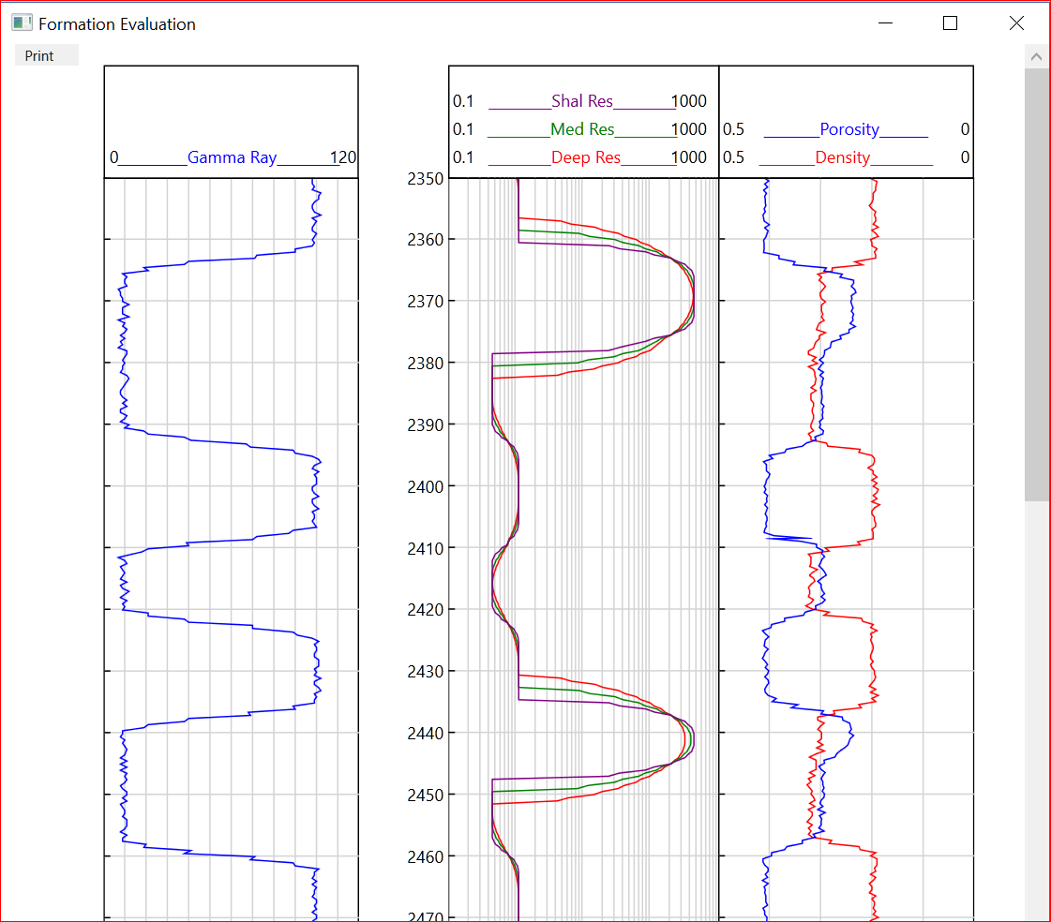

Data Storage
The data storage component of the simulator is a SQL database with tables to store the various settings and measurements. The data tables are designed to allow creation and management of multiple wells.
In addition to storing data, the database contains a number of complex Stored Procedures. These are compiled code blocks which retrieve data and feed it to the Simulation Engine, as needed. Frequently the data is stored in a simpler, raw form, and the Stored Procedures perform complex calculations and transformation to present the results in the format needed.
As an example, Surveys are stored in a table which is relatively simple. There are 3 essential elements which define a survey point:
- Depth
- Inclination
- Azimuth
However, to accurately generate a plot of the surveys, these three items need to be transformed into X, Y, Z coordinates of True Vertical Depth, Northing, and Easting. These are cumulative measures so that for each survey, we need to compare it to the previous survey point, determine the change between surveys, and then sum the total changes up until, and including that point to determine it’s XYZ Coordinate values. These calculations are performed upon the raw survey data by the Stored Procedure and the appropriate results are passed to the application for display.

General Data Considerations
For the purpose of the simulator, data is provided for specific aspects of the well, and data is stored and managed for these different aspects.
Thinking about an abstract well, there are a number of object which need to be considered for it’s construction.
A well would have an associated Rig which is used to drill it, and the Rig Sensors may need calibrations to render raw counts into output values. The well would also have a number of properties, such as the current hole depth, the current bit depth, etc.
In order construct the well, the simulator would also need to know about:
- The Bottom Hole Assembly (tools included, lengths, etc.)
- The Well Plan (the geometric path intended to be drilled)
- Surveys (the measures taken thus far along the trajectory)
- The Pipe Set (the joints of pipe being used, or to be used, weights, lengths, etc.)
- The Formation (physical properties of the model which is being drilled)
- Logging Results (a repository of the measures taken when drilling to create logs)
Some of these items may also contain properties or sub items. For instance, a formation may also have a Formation Dip property, and the Bottom Hole Assembly is composed of items, which may each have sensors.
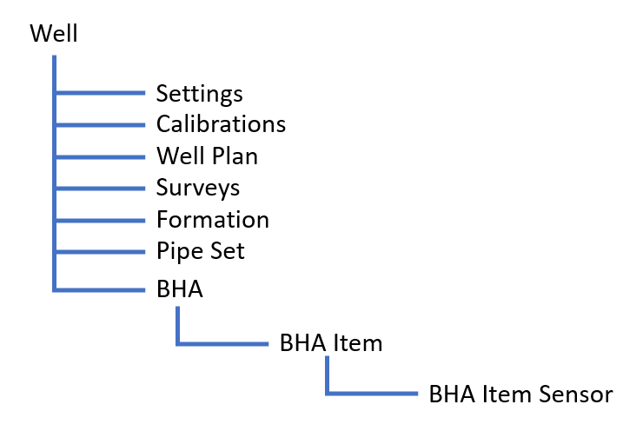
Looking at this in more detail, we can describe the well as
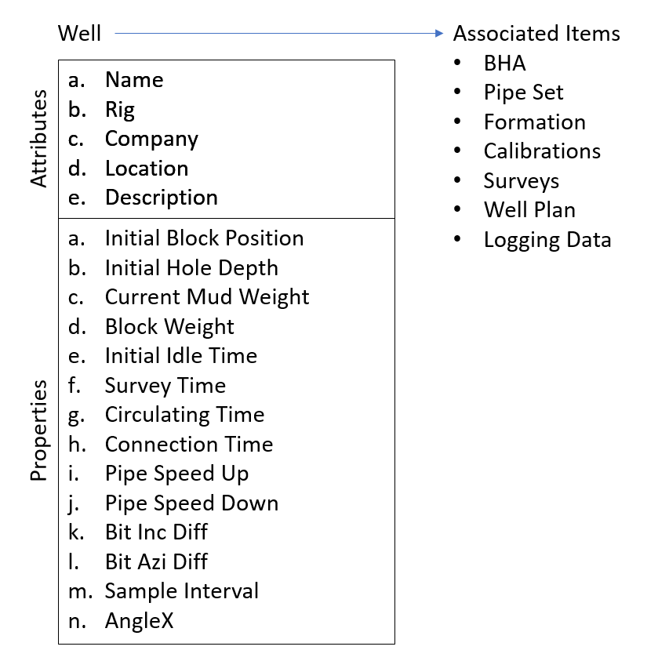
Let’s look at the these in more detail.
The Attributes are just informational tags. They are really somewhat arbitrary, but can be used to identify and distinguish wells when working in a multiple well environment.
Well Properties:
- Initial Block Position – provides a reference point for the simulator when starting.
- Initial Bit Depth – this is a starting point for the simulator. This is nominally the Kelly length about the current hole depth at the start. Note: The Pipe In Hole amounts, Block Height, and BHA Length need to sum up, so that the total pipe in hole plus BHA less the block height will equal the Initial Bit Depth.
- Initial Hole Depth – this is a starting point. The Initial Hole Depth needs to be the Bit Depth plus the Kelly Length, less the stick up of the pipe in the slips. Also, the last real reference point is the last survey. Last Survey Depth was taken when the Kelly was at the rig floor. The amount of new hole drilled would only equal the length of Kelly. Mathematically Initial Hole Depth is the Kelly Length Plus the Last Survey Depth Plus the length behind bit of the survey.
- Mud Weight – the density of the drilling fluid. It is used to compute the buoyancy of the drill pipe to determine hookloads
- Block Weight – the weight of the block when no load is present.
- Initial idle time – the time the simulator sits idle when starting as the completion of making a connection.
- Survey Time – the length of time to hold the pipe still and have the pumps start for the survey to be generated and transmitted.
- Circulating Time – the length of time to sit, pumping, while at Kelly down. This is needed to ensure cuttings are moved back past the bit so they don’t fall in and stick the pipe.
- Pipe Speed Up – this is the maximum speed the pipe would travel when picking up. It rarely ever gets there, and at some points, only percentages of this value are use.
- Pipe Speed Down – is similar to Pipe Speed Up, but in the downward direction
- BitIncDiff – this is a correction value. It is the difference between what you want the inclination at the bottom of the hole to be, different from the inclination at the last survey. It is not uncommon that the survey point may be ~50 – 60 feet behind the bit. The hole is then drilled the length of the Kelly. This means that at the simulator start, there is potentially ~100 feet of hole which has been drilled but not measures. If the last few joints were drilled straight, the last survey inclination could be used when taking the next survey. However, we calculate a “Blind Hole” to allow the last joints to have been drilled directionally. Blind Hole is a data table which projects the trajectory from the last survey to the Initial Hole Depth so that when the survey point is within that hole section, the Blind Hole can provide the Inclination and Azimuths at that survey point. Blind Hole uses the BitIncDiff to calculate the amount of change to apply to the blind hole.
- BitAziDiff – is the Difference of the Azimuth at hole bottom from the last survey. Similar to BitIncDiff but for Azimuth.
- Sample Interval – a variable which tells the Simulator how much new hole should be drilled for the Logging data to be sampled and for a new Blind Hole Calculation to be computed and added to the Blind Hole data set.
- AngleX – Survey Tools such as MWD tools use both Magnetometer’s and Accelerometers for providing “Toolface” with is the tool’s orientation. When nearly vertical, Toolface is typically referenced azimuthally to show the direction the tool is pointing. As inclination increases, it is preferred to orient the tool with respect to “Up” or Gravity High Side. AngleX is the inclination value where the tool switches mode to transmit Gravity Toolface rather than Magnetic Toolface, or switches back.
Let’s review some of the associated Well items in more detail.
- Well Plan – This is the table of Measured Depth, Inclination, and Azimuth which define the desired well path.
- Surveys – This is the table of Measured Depth, Inclination, and Azimuth which are measured during drilling. The table can be preloaded for sections of the well which may already have been drilled, and will be added to with each new survey.
- Calibrations – a table holding values needed for sensor count translations. Typically, a sensor may take a reading of a value at a known position. Taking a reading at a second know position yields a difference in counts. Thus, you have a known difference and a count difference. We can then determine a gain and offset which can be applied to sensors counts to provide accurate output values.
- Pipe Sets – This table holds a listing of Drill Pipe Joints, identified by a Joint Id number as a sequence number to use, the length of the Joint, the type of Joint, which stand it belongs to, and the weight per foot for that joint type.
- Formation – This is a table for storing a formation model. A model is defined as a series of True Vertical Depth values, and with each TVD Depth, a series of formation properties for that depth. These properties include:
  - Formation Hardness - a numeric value which indicates how hard the formation is to drill.
  - Water Saturation – Porous reservoir materials have some fluid filling the pore space. The Water Saturation is the percentage of the pore space occupied by water. When Water Saturation is determined, the non-water saturation percentage can be assumed to be filled with Oil or Gas.
  - Shaliness – a value which represents the percentage of Shale in the layer. This is used to compute a Natural Gamma Reading
  - Density – is a raw value that would be measured by a Density tool. It gives a composite density which is the density of rock material and the pore space filled with fluid. When this is compared to the Pure Rock Matrix density, a Porosity Percentage can be determined.
  - Nphi – a measure of the Hydrogen Index, or the abundance of Hydrogen present in the formation. This is calibrated so that the Hydrogen present corresponds to the formation porosity when measuring a “Wet Sand” or sandstone filled with water.
  - Matrix – this is the value of the pure solid rock making up the nominal formation. Generally we deal with Sandstone (2.65 g/cm) and Limestone (2.71 g/cm). With a known matrix, the Density value can be used to calculate a Dphi or Density Porosity.
  - Rw – the Resistivity value of connate water filling the pore space.
  - Permeability – a value which represents how easily a fluid can flow through a porous rock.
  - Pressure – a value showing the equivalent mud weight for that depth.
  - Fluid Density – a value showing the density of the fluid filling the pore space. Typically, this is 1 g/cm for water, but could be less for oil and even less for gas. This is used to provide a distinctive “Crossover” effect when using Gas is present.
- Logging Data – this table is used to store the logging values that are calculated as the sensors pass through the specific zones during the drilling operation. The data is normalized and can be called out for presentation in the log displays.
- Bottom Hole Assembly, or BHA – This represents a combination of tables. We start with a BHA table that contains basic details such as the Name, a Description, and then BHA performance tendencies when sliding or rotating. An associated table lists the specific items which are combined to make a BHA. This lists the Items reference ID, and the Sequence where the item is installed within the BHA. A separate reference table holds the details about the available items for the BHA. The BHA Items table lists the Items Name, Length, Description, Weight Per Foot, and the type of item is, (MWD, Motor, Bit, etc). A separate associated table may hold Sensor detail information that is associate with a BHA Item. The Sensor Detail would include the Sensor’s name, description, it’s measure point from the bottom of the tool, the sensor’s depth of investigation, and the type of measure it makes. Conceptually the BHA system would look like this:
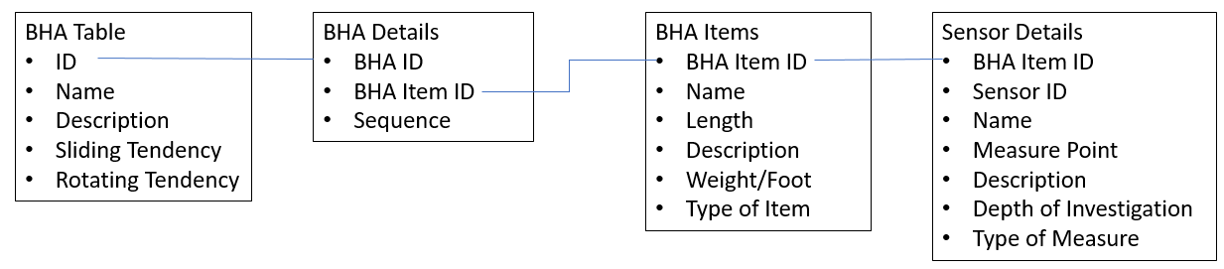
This BHA arrangement allows for a BHA to be defined and shared across multiple wells. The BHA Items can be used in different BHAs, and the BHA is completely configurable by the Operator.

Description of General Simulator Processes
When the simulator is setup and configured, with a selected well, and the well values edited, etc, a series of initialization occur when the simulator starts, not specifically in this order:
- Survey Data is loaded. The Raw Surveys are pulled into various views and stored procedures process a calculated table of
    - Depth
    - Inclination
    - Azimuth
    - TVD
    - Northing
    - Easting
For each survey in the table for that well.
- Calibrations are loaded into a memory resident table for quick access
- The BHA tables will be combined and loaded into a reference table which will have the tools, the sensors, and the distance behind the bit for each sensor
- The Pipe Set details will be loaded. Calculations will be performed to determine how much pipe is in the hole, which joint is the current joint to be drilled, and if an adjustment is needed to make math right for the last survey depth, BHA lengths, and pipe. If needed, a “Pup Joint” will have it’s length adjusted to correct for all of the depths. Also, Initial Bit Depth and Initial Hole Depth will be adjusted.
- The Formation Data will be loaded for quick access
- All of the initial settings will be loaded
At this point, the simulation is ready to begin.

Basic Archie’s Equation
$${Sw=\sqrt{ Rw/(Rt* ∅}}^{2}$$
Where:
Sw is the Water Saturation
Rw is the Connate Water Resistivity
Rt is the Formation Measured Resistivity
Ø is the Porosity
Thus
Water Saturation is the SquareRoot of (the Connate Water Resistivity divided by the Product of the Formation Measured Resistivity and Porosity Squared)

We also know that
Ø = (Ø_{Density} + Nphi)/2
Where Nphi is the Neutron Porosity.
How do we get Ø_{Density} ?
ØDensity = 1 –((Density – Fluid)/(Matrix – Fluid))
Density is the Formation Reading
Fluid is the Density of the fluid filling the pore space (Nominally water at 1 g/cc)
Matrix is the solid rock material.
Remember, when dealing with a porous formation, the Density reading would be reading a mixture of solid rock and something else. In essence this is just saying the if you account for the fluid, comparing what you measure against what you would measure if there were zero pore space, the difference is accounted for by pore space. Porosity is just a representation of how much is the mix.
If we took an example,
- Sandstone - Matrix = 2.65
- Water – Fluid = 1
A density reading of 2.3 g/cm is
ØDensity = 1 – ((2.3 -1)/(2.65-1))
_{= 1 – (1.3/1.65)}
_{= 1 - .79}
_{= .21}
_{or 21% Porosity!}
From the Formation table we can look up the following values
- Sw - Water Saturation
- Rw – Connate Water Resistivity
- Dens – Formation Density Measured
- Nphi – Neutron Porosity
- Matrix – Formation Matrix Material
So we can calculate the effective porosity
ØDensity = (1 – ((Dens -1)/(Matrix-1)) + Nphi)/2
And we know that
$${Sw=\sqrt{ Rw/(Rt* ∅}}^{2})$$
What we don’t know but need to provide for the Simulation is the Rt value.
We can solve for Rt
Sw² = Rw/(Rt* Ø²)
Or
Rt = Rw/( Sw²* Ø²)
So we can calculate and determine what a tool should measure as a Resistivity value based upon it’s location in the formation. While drilling, the bit depth will be seen as a measured depth, but we store in the Blind Hole Dataset a current TVD. Knowing the Bit TVD, the Bit Inclination, and the distance behind the bit of the sensor, we can determine the Logging Sample Point TVD.
Logging Point TVD = BitDepth_{TVD} – (Sin(Bit Inclination) * Distance Behind Bit)
This tells us sensors TVD, so we can then reference the correct TVD value from the Formation model.

Shoulder Bed Effects
Each logging sensor may have a different depth of investigation. As such, it may be able to sense more than just the formation bed at the corrected Sensor Depth.
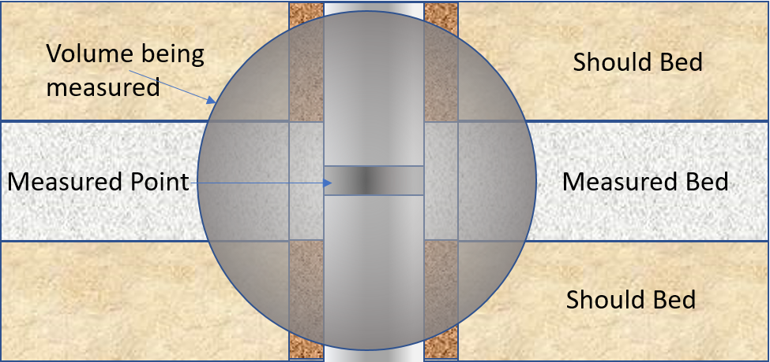
The volume of investigation is sensing more than just the bed at the location of the sensor measure point. In an inclined or horizontal well, the sensor may start to see influence of near beds before they are encountered.
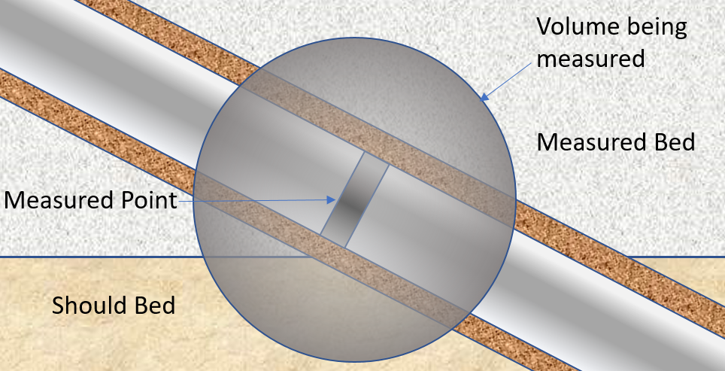

In order to accommodate this, we determine the depth in the formation for the sample, and then take a series of measures above and below the sample point, for the given depth of investigation.
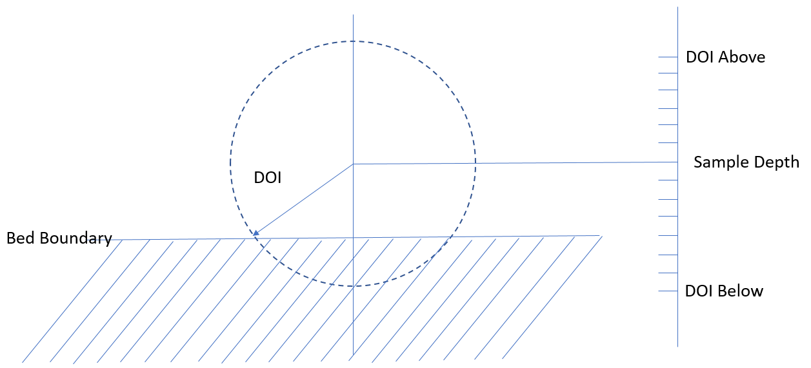

Each of these samples is then used as a weighted averaged, such that the samples closest to the Sample depth has greater value and samples more distant are of lesser weight. This allows the tools to respond by seeing and being influenced by beds as they approach, in a highly realistic manner.

Without near bed corrections, a typical log response may be somewhat block and abrupt.
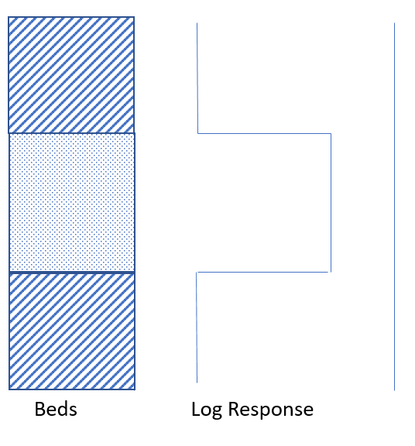
With the near bed correction, responses would be more like this:
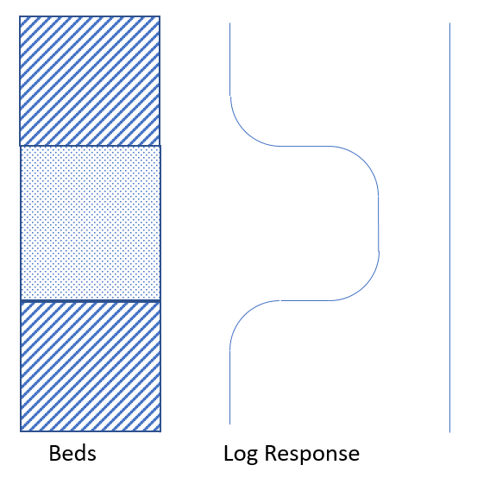

Calculations for Incorporating Formation Dip
Formation Dip will be defined with a degree of variance from horizontal in the downward direction, and the azimuth of that variance.
The Blind hole table needs to be extended to include
Total Displacement
Displacement Azimuth
Total displacement is the absolute horizontal distance from the origin position. The Displacement Azimuth is the direction of that displacement.
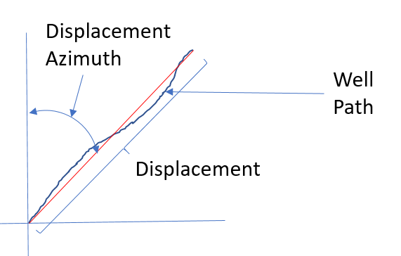
The Displacement is calculated as
$$Displacement=\sqrt{{Northing}^{2}+ {Easting}^{2}}$$
The Displacement Azimuth is a little more complicated.
$$Displacement Azi=$$ | If Easting < 0 Then
 | 360 – Acos(Northing/Disp)
 | Else
 | Acos(Northing/Disp)

Remember that frequently we need to convert to Degrees from Radians in our code when using Trigonometry functions.
Having the Displacement and Displacement Azimuth provide detail about the Well Geometry. This tells us how far horizontally we are from the well starting point. To understand where we are in the dipping formation we need to account for the dip direction and magnitude. We need to calculate the portion of dip that we would see along the direction of the displacement. If the Dip Azimuth is the same as the Displacement Azimuth, then full Dip amounts would be applied. If the 2 Azimuths were perpendicular, then the Effective Dip would be 0. And if the Azimuths were in opposite directions, then we are drilling up dip and the Dip values would be opposite.
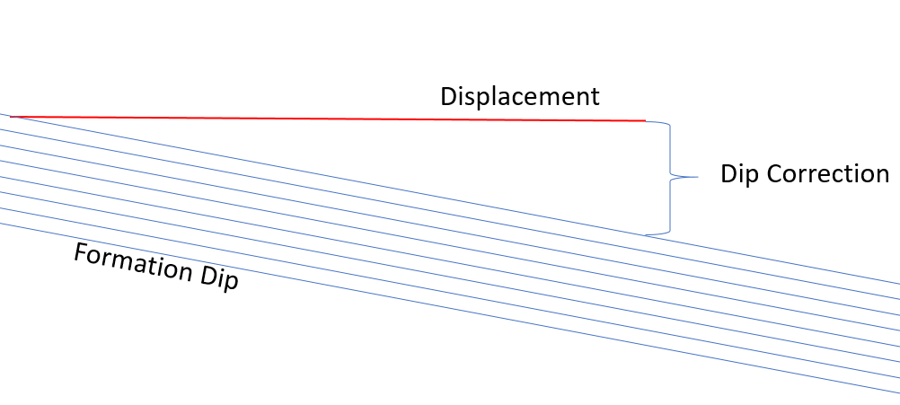
First, we need to determine the effective Dip. This is
$${Dip}_{Eff}=Cos \left({Azi}_{Disp}-{Azi}_{Dip}\right)*Dip$$

Or the Effective Dip is the Cosine of the difference between the Displacement Azimuth and Dip Azimuth, multiplied by the Dip.
Once the Effective Dip is known, we can determine a Dip Correction as
$$Dip Correction=Displacement*Sin({Dip}_{Eff})$$
Finally, the Dip Correction can be subtracted from the TVD of the Sample Point to place the Sample Point in the Dip Adjusted location within the Dipping Formation Model

